Review page 30 in textbook
Key Topics
- Be able to describe how energy travels by waves
- Mechanical waves need a medium to transfer the energy from one place to another
- Mechanical waves are classified by movement and can be transverse waves or longitudinal waves
- Know the parts of a transverse wave (pg. 8)
  - Crest, trough, amplitude, wavelength, resting point
- 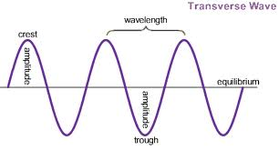
Resting Position

- Know the parts of a longitudal wave (pg. 10)
Compression, Rarefaction
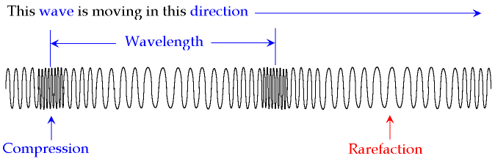

- Be able to define the four basic properties of a wave
Wavelength, Frequency, Amplitude and Speed
- Know the speed formula (S=W x F )
WAVELENGTH = $\frac{SPEED}{FREQUENCY}$
FREQUENCY = $\frac{SPEED}{wAVELENGTH}$
Speed = Wavelength x Frequency

- Be able to recognize the difference between reflection and refraction and diffraction
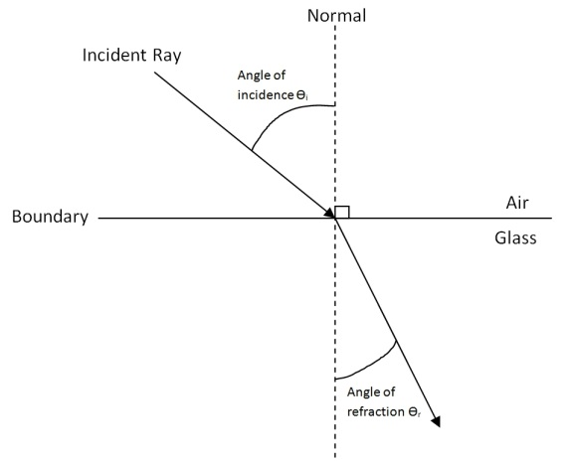
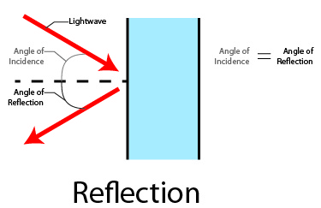

Refraction- When a wave enters a new medium at an angle, one side of the wave changes speed before the otherside, causing the wave to bend. (Think the angle of a straw in water.)
Reflection – When an object or a wave hits a surface through which it cannot pass, it bounces back. (Think a ball bouncing off a wall)

Items to help you study
-Textbook, Notes, Teacher website (sample test, PowerPoint notes, websites) Cheat Sheet (index card) Homework/ Quizzes/ Worksheets

